BA Capstone Project: Checkpoint 2

Spreadsheet & Statistical Analysis
Group Name: STING RAY
Course & Section: BED 106 - Business Analytics
Date: [INSERT SUBMISSION DATE]
Team Members & Roles:
Christy Mae R. Gurrea — Project Lead / Analyst / BI Developer / Visualizer
Ana Marie Boyles — Data Engineer
Justine Punay — Statistician / Modeler

Task 2.1 — Spreadsheet Analytics Report

Sheet 1: Cleaned Data
The cleaned encounter-level dataset from Checkpoint 1 (101,766 encounters) was imported into Excel as a Named Table (CleanedData, 26 columns), joined against the discharge_disposition and admission_type lookup values so pivot tables and formulas can reference readable labels directly, plus a High_Risk_Flag helper column (3+ diagnoses, 1+ prior inpatient visit, 5+ day stay -- the same rule used in Checkpoint 1, Query 4.2).
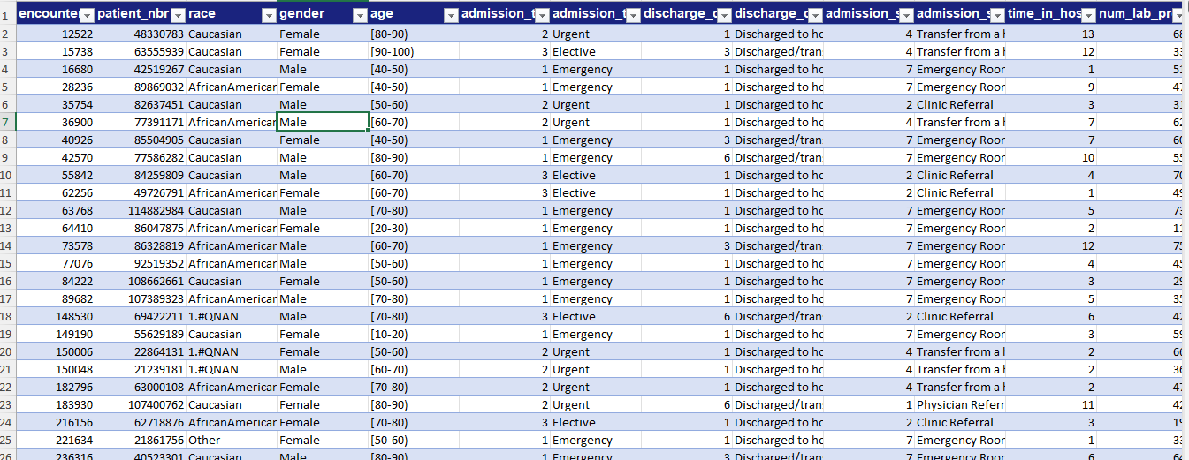
Cleaned Data

Sheet 2: Pivot Analysis
Three native Excel PivotTables summarize key business metrics from the CleanedData table (n = 101,766).
Pivot Table 1: Readmission Outcome Summary
Row Labels | Encounter Count | Avg Length of Stay (days) | Avg Medications | Avg Prior Inpatient Visits
<30 | 11,357 | 4.77 | 16.90 | 1.22
>30 | 35,545 | 4.50 | 16.28 | 0.84
NO | 54,864 | 4.25 | 15.67 | 0.38
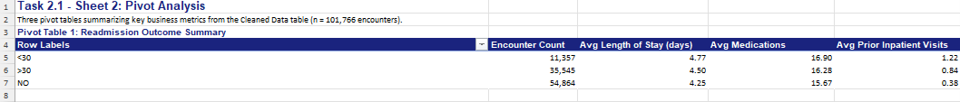
Pivot Table 1
Pivot Table 2: Age Group Profile
Row Labels | Encounter Count | Early Readmit Rate | Avg Prior Inpatient Visits
[0-10) | 163 | 1.84% | 0.09
[10-20) | 723 | 8.16% | 0.82
[20-30) | 1,683 | 13.84% | 1.28
[30-40) | 3,842 | 10.93% | 0.77
[40-50) | 9,943 | 10.91% | 0.76
[50-60) | 17,393 | 9.65% | 0.62
[60-70) | 22,559 | 11.12% | 0.60
[70-80) | 26,117 | 11.78% | 0.61
[80-90) | 16,789 | 12.05% | 0.59
[90-100) | 2,554 | 10.57% | 0.49
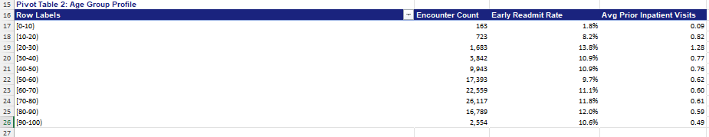
Pivot Table 2
Pivot Table 3: Discharge Disposition Resource Use
Row Labels | Encounter Count | Avg Medications | Avg Lab Procedures | Early Readmit Rate
Discharged to home | 60,234 | 14.80 | 41.98 | 9.30%
Discharged/transferred to SNF | 13,954 | 17.96 | 45.52 | 14.66%
Discharged/transferred to home with home health service | 12,902 | 18.77 | 43.97 | 12.70%
NULL (not documented) | 3,691 | 16.20 | 43.04 | 12.44%
Discharged/transferred to another short term hospital | 2,128 | 15.56 | 44.39 | 16.07%
Discharged/transferred to another rehab facility | 1,993 | 20.32 | 42.46 | 27.70%
Expired | 1,642 | 18.48 | 52.40 | 0.00%
Discharged/transferred to another type of inpatient care institution | 1,184 | 16.18 | 46.56 | 20.86%
Not Mapped | 989 | 14.41 | 39.01 | 9.30%
Discharged/transferred to ICF | 815 | 15.08 | 42.17 | 12.76%
Left AMA | 623 | 12.52 | 44.98 | 14.45%
Discharged/transferred to a long term care hospital | 412 | 23.43 | 45.97 | 7.28%
Hospice / home | 399 | 16.57 | 47.68 | 4.76%
Hospice / medical facility | 372 | 16.08 | 47.58 | 6.45%
Discharged/transferred/referred to a psychiatric hospital | 139 | 14.51 | 46.23 | 36.69%
Discharged/transferred to home under care of Home IV provider | 108 | 18.56 | 45.37 | 13.89%
Discharged/transferred within institution to Medicare swing bed | 63 | 17.52 | 45.25 | 44.44%
Discharged/transferred to a nursing facility (Medicaid, not Medicare) | 48 | 17.04 | 41.48 | 14.58%
Admitted as an inpatient to this hospital | 21 | 15.38 | 43.29 | 42.86%
Discharged/transferred/referred to this institution for outpatient services | 14 | 12.36 | 17.36 | 0.00%
Discharged/transferred/referred to another institution for outpatient services | 11 | 9.91 | 16.64 | 0.00%
Expired at home, hospice (Medicaid only) | 8 | 11.75 | 42.25 | 0.00%
Neonate discharged for neonatal aftercare | 6 | 12.67 | 54.00 | 0.00%
Discharged/transferred to a federal health care facility | 5 | 16.00 | 47.80 | 0.00%
Still patient / expected to return for outpatient services | 3 | 14.00 | 37.33 | 66.67%
Expired in a medical facility, hospice (Medicaid only) | 2 | 19.00 | 35.50 | 0.00%

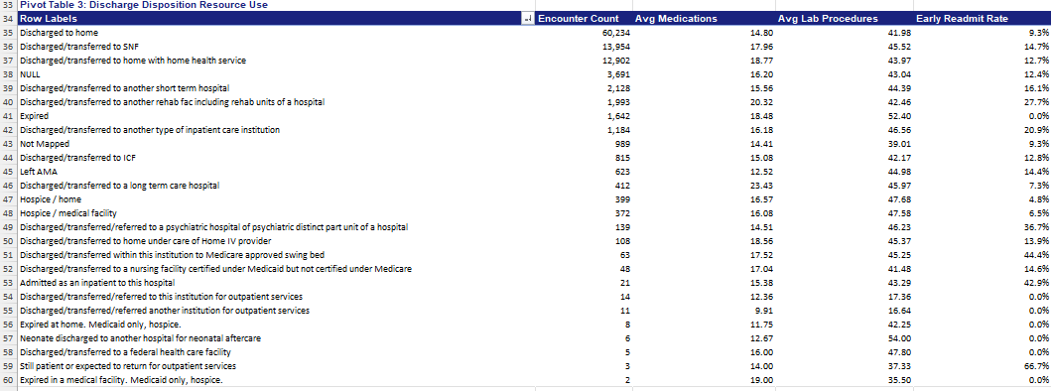

Pivot Table 2

Sheet 3: Pivot Charts
Three charts, each built directly from a PivotTable on Sheet 2, so they update automatically if the PivotTables are refreshed.
Chart 1 — Length of Stay & Prior Admissions by Readmission Outcome
Clustered column chart comparing average length of stay and average prior inpatient visits across the three readmission outcomes (<30, >30, NO), sourced from Pivot Table 1.

Chart 1
Chart 2 — Encounter Volume & Early Readmit Rate by Age Group
Combo chart (columns for encounter count, line for early-readmit rate) across the ten age bands, sourced from Pivot Table 2.

Chart 2
Chart 3 — Average Medications by Discharge Disposition (sorted by volume)
Bar chart of average medications per encounter, sourced from Pivot Table 3, sorted by encounter volume so the largest discharge routes are easiest to compare.

Chart 3

Sheet 4: Formulas Showcase
Six Excel functions demonstrated against the CleanedData table (n = 101,766 encounters).
Business Question | Excel Function(s) | Live Formula
How many encounters were readmitted within 30 days? | COUNTIF | =COUNTIF(CleanedData[readmitted],"=<30")
Total medications administered across early-readmission (<30-day) encounters | SUMIF | =SUMIF(CleanedData[readmitted],"=<30",CleanedData[num_medications])
Average length of stay for early-readmission encounters | AVERAGEIF | =AVERAGEIF(CleanedData[readmitted],"=<30",CleanedData[time_in_hospital])
Share of encounters flagged High-Risk (helper column: 3+ diagnoses, 1+ prior inpatient, 5+ day stay) | IF (+ AVERAGE) | =AVERAGE(CleanedData[High_Risk_Flag])
Discharge disposition description for discharge_disposition_id = 11 | XLOOKUP | =XLOOKUP(11,CleanedData[discharge_disposition_id],CleanedData[discharge_disposition])
Early readmission rate, formatted as a percentage string for a report/label | TEXT | =TEXT(COUNTIF(CleanedData[readmitted],"=<30")/COUNTA(CleanedData[readmitted]),"0.0%")
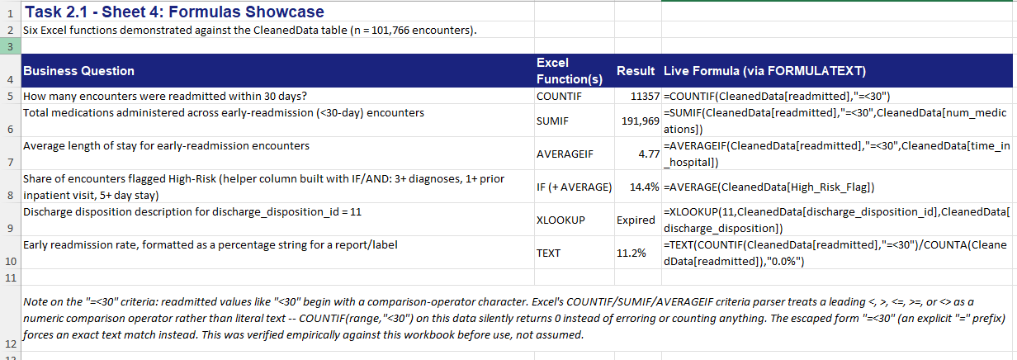
Formulas Showcase
Note on the "=<30" criteria: values like "<30" begin with a comparison-operator character. Excel's COUNTIF/SUMIF/AVERAGEIF criteria parser treats a leading <, >, <=, >=, or <> as a numeric comparison rather than literal text -- COUNTIF(range,"<30") on this data silently returns 0 instead of counting anything. The escaped form "=<30" forces an exact text match instead. This was verified empirically against this workbook before use, not assumed.

Task 2.2 — Descriptive Statistics Report
Three numerical variables from CleanedData (n = 101,766 encounters).
Statistic | Length of Stay (days) | Number of Medications | Number of Diagnoses
Mean | 4.40 | 16.02 | 7.42
Median | 4 | 15 | 8
Mode | 3 | 13 | 9
Standard Deviation | 2.99 | 8.13 | 1.93
Variance | 8.91 | 66.06 | 3.74
Range | 13 | 80 | 15
Minimum | 1 | 1 | 1
Maximum | 14 | 81 | 16
Count (n) | 101,766 | 101,766 | 101,766

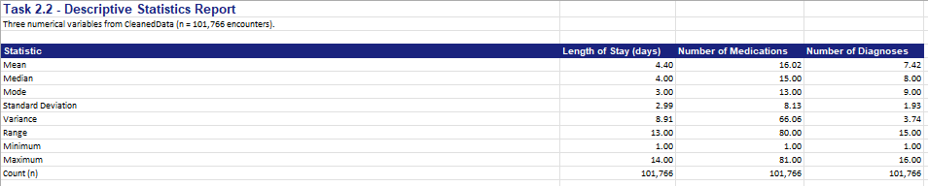

Descriptive Statistics Report

Frequency Distribution & Histogram: Length of Stay (Days)
Days in Hospital | Encounter Count | % of Total
1 | 14,208 | 13.96%
2 | 17,224 | 16.93%
3 | 17,756 | 17.45%
4 | 13,924 | 13.68%
5 | 9,966 | 9.79%
6 | 7,539 | 7.41%
7 | 5,859 | 5.76%
8 | 4,391 | 4.31%
9 | 3,002 | 2.95%
10 | 2,342 | 2.30%
11 | 1,855 | 1.82%
12 | 1,448 | 1.42%
13 | 1,210 | 1.19%
14 | 1,042 | 1.02%

Histogram Chart

Narrative Interpretation
INTERPRETATION -- TO BE COMPLETED BY THE STUDENT (per course policy, AI-generated analysis is not permitted):
- Length of Stay: compare the mean vs. median above -- what does the gap (or lack of one) suggest about skew/outliers? What does the histogram shape tell you?
- Number of Medications: how does the spread (SD vs. mean) compare to Length of Stay -- is medication count more or less variable?
- Number of Diagnoses: what does the min/max/range suggest about how complex the average encounter is? Tie each variable back to Key Business Question 2 from Checkpoint 1.

Task 2.3 — Correlation Analysis
Two pairs of variables from the business problem, each with a Pearson correlation coefficient computed on the full dataset (n = 101,766) and a scatter plot with trendline built on a random sample (seed = 42, n = 600) for chart readability.

Pair 1: Length of Stay vs. Number of Medications
Pearson r (CORREL, full dataset, n = 101,766): 0.4661

Pair 1: Length of Stay vs. Number of Medications

Pair 2: Length of Stay vs. Number of Lab Procedures
Pearson r (CORREL, full dataset, n = 101,766): 0.3185

Pair 2: Length of Stay vs. Lab Procedures

Interpretation
INTERPRETATION -- TO BE COMPLETED BY THE STUDENT (per course policy, AI-generated analysis is not permitted):
For each pair: is this weak/moderate/strong (use 0.1/0.3/0.5 as rough thresholds)? What does it mean operationally (e.g., for pharmacy/staffing or lab-capacity planning)? Does correlation imply causation here -- why or why not? Note: the chart trendline/R² is fit on the n=600 sample for visual clarity only; the Pearson r values reported above are the authoritative full-dataset figures.

Task 2.4 — Simple Linear Regression
Predicting Length of Stay from Number of Medications (n = 101,766 encounters). Builds on Pair 1 from Task 2.3.

Model Summary
Regression Statistic | Value
Dependent variable (Y) | Length of Stay (time_in_hospital, days)
Predictor variable (X) | Number of Medications (num_medications)
Sample size (n) | 101,766
Slope (b) | 0.1712
Intercept (a) | 1.6530
R (Pearson correlation) | 0.4661
R-squared | 0.2173
Standard Error of the slope (SE_b) | 0.001019
t-statistic (b / SE_b) | 168.08
Degrees of freedom (n-2) | 101,764
p-value (two-tailed, H0: slope = 0) | < 0.0001

Regression Equation: Length of Stay = 1.653 + 0.171 x (Number of Medications)

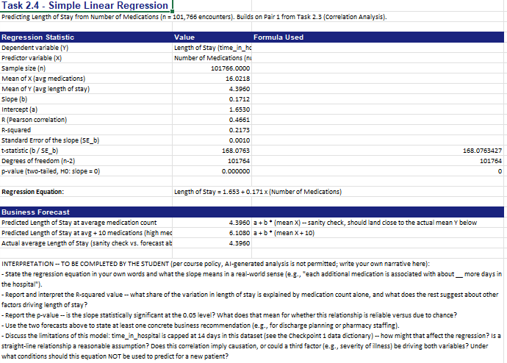

Simple Linear Regression

Business Forecast
Scenario | Predicted Length of Stay (days)
At average medication count (~16.0 medications) | 4.40
At average + 10 medications (~26.0, high med-complexity patient) | 6.11
Actual average Length of Stay (sanity check) | 4.40

Interpretation & Limitations
INTERPRETATION -- TO BE COMPLETED BY THE STUDENT (per course policy, AI-generated analysis is not permitted):
- State the regression equation in your own words and what the slope means in a real-world sense (e.g., "each additional medication is associated with about __ more days in the hospital").
- Report and interpret the R-squared value -- what share of the variation in length of stay is explained by medication count alone, and what does the rest suggest about other factors driving length of stay?
- Report the p-value -- is the slope statistically significant at the 0.05 level? What does that mean for whether this relationship is reliable versus due to chance?
- Use the two forecasts above to state at least one concrete business recommendation (e.g., for discharge planning or pharmacy staffing).
- Discuss the limitations of this model: time_in_hospital is capped at 14 days in this dataset (see the Checkpoint 1 data dictionary) -- how might that affect the regression? Is a straight-line relationship a reasonable assumption? Does this correlation imply causation, or could a third factor (e.g., severity of illness) be driving both variables? Under what conditions should this equation NOT be used to predict for a new patient?

Task 2.5 — Trend / Seasonality Analysis
Not applicable to this dataset -- justification below (per task instructions: "if applicable").

Why this task doesn't apply
The Diabetes 130-US Hospitals dataset (data/diabetic_data.csv) does not include an admission date, discharge date, or any other timestamp field for each encounter -- only encounter_id and patient_nbr, which are database identifiers, not calendar dates (see the Task 1.2 Data Dictionary in the Checkpoint 1 report). Without a real date field, there is no way to plot the data over time, identify a genuine trend or seasonal pattern, or project "the next 3-6 periods" the way this task requires. Fabricating a timeline that isn't in the source data would go against the course's data-fabrication policy (Section 3.2 of the project guide).

What was done instead
Task 2.4 (Simple Linear Regression) models the relationship between two continuous variables that ARE in the data -- Number of Medications predicting Length of Stay -- which is the applicable quantitative analysis available for this checkpoint given the dataset's structure.

